VOCABULARY
- Read the clues below and write the missing travel words in this crossword.
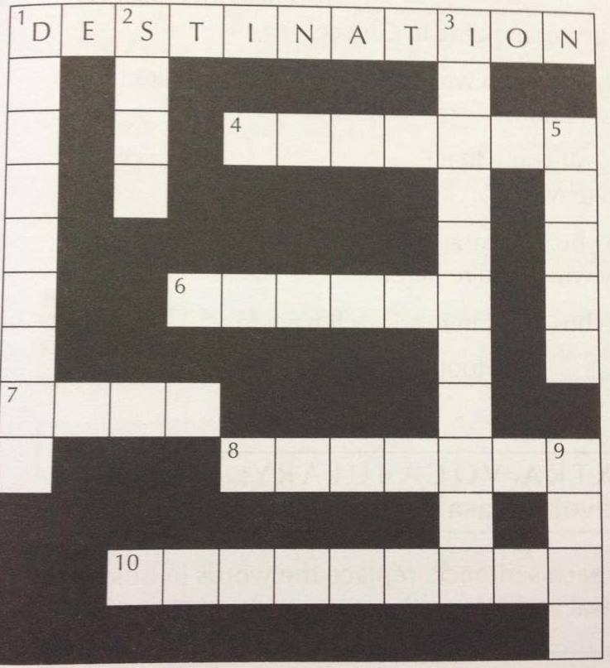
Across
- The place you travel to.
- The place where bags are checked for illegal items.
- To go on a journey.
- A kind of journey.
- The industry which helps people to go on holiday.
Down
- Papers with official information for travel (e.g. passport, tickets, visa).
- To live in a place for a temporary period.
- You have this o protect against a disease.
- A special place to see (e.g. famous monument, building, palace).
- To come together with new people on holiday.

- Write one of these verbs in each sentence 1-10.

get / respect / find out / see / broaden / become / explore / find

- I think it’s good for young people to take a gap year and travel to _broaden__________ their horizons.
- We’re going to __explore___________ some old temples in the mountains.
- Lots of people travel to __find________ themselves as much as to visit new places.
- I like holidays where you just __get________ away from it all on a beach doing nothing.
- My daughter has ___become_________ more independent since her trip to Thailand.
- So what sights did you _see_________ while you were there?
- It’s important to _respect____________ the local culture and act in the correct way.
- Did you _find out_________ what time the train leaves for Rome?

- Match the verb to the particle and complete the sentences.

set get stop  get look carry | out on off  around back to

- Marco Polo __set______ __out_______ in 1271 with his father to China.
- Let’s __stop________ _off_________ in Venice for a few days before continuing to Greece.
- What time do we ___get_______ __to_________ our destination?
- I’ll call you when I ___get______ ___back_______ from my trip to Mexico.
- Do you have any time to ___look_______ ___around________ our city while you’re here?
- The bus stops here so we’ll have to ____carry_______ __on_________ by foot.

KEY LANGUAGE: discussing advantages and disadvantages

- Match a beginning 1-7 with an ending a-g, to make the correct expressions.

- I suggest (b) a) a good idea to …
- How (f) b) we …
- On the other hand (e) c) for and against …
- I think we (d) d) should …
- There are arguments (c) e) but on the other hand …
- It’d be (a) f) about …
- Another disadvantage (g) g) is that …

- Use parts of the expressions in Exercise 1 to complete this discussion.

A: Have you thought any more about where to go on holiday?
B: Yes, I was reading about something called eco-tourism. I think (1) _we should__ do something like that. What do you think?
A: Well, I’ve read about that too, and there are (2) __arguments for and against____ .
B: What do you mean?
A: Well, on the (3) ___one hand__ you fly to interesting places and help with projects, but on the (4) _other hand____ having lots of people travelling to parts of the world with ecological problems is probably causing more problems. Another (5) _disadvantage____________ is that we don’t have enough money to do that! It’s quite expensive.
B: so, where should we go?
A: Well, I agree that it’d be (6) _a good idea to_______________ do something different rather than just sitting on a beach. (7) __How_____________ about going on an archaeological dig?
B: What’s that exactly?
A: Well you travel to an ancient place and help dig for old buildings and objects. A friend of mine is working on one in the Sahara desert. I (8) __think____________ we should join.

GRAMMAR

- Read the text about climate change. Choose the correct form, A or B, to complete the sentence.

At the moment, scientists agree that the world’s climate (1) ________ warmer over the past 50 years, but they disagree about the causes. Some believe that human activities (2) _________ climate change. They argue that for 1,000 or 2,000 years before 1850, when records (3) ___________, the temperature was more or less stable. Short warm or cold periods (4) __________ during that time, but the climate always (5) _____ to the same level. However, since the Industrial Revolution, human beings (6) ______ more and more fossil fuels, such as coal and oil. In 1800 the atmosphere (7) ________ around 280 parts per million of carbon dioxide (CO2) Since then there (8) _______ an increase of about 31 %. This extra carbon dioxide (9) ________ the world’s temperature because of the greenhouse effect.
Other scientists disagree that human activities over the past 50 years (10) ___________ global warming. They point out that volcanoes and other natural processes (11) ________ CO2 into the atmosphere, and that human activity (12) _______ a rise in CO2 of only three per cent.
In 1999, 156 countries (13) _______ the Kyoto protocol, part of a United Nations agreement on climate change, which (14) ________ into force in 2005. They (15) ________ to reduce their emissions of CO2 and other greenhouse gases, although so far, some countries, such as the USA and Australia, (16) _______ any action.

1 | - become | - has become
2 | - caused | - have caused
3 | - began | - have begun
4 | - occurred | - have occurred
5 | - returned | - has returned
6 | - burned | - has burned
7 | - contained | - has contained
8 | - was | - has been
9 | - raised | - has raised
10 | - caused | - have caused
11 | - always released | - have always released
12 | - contributed | - has contributed
13 | - signed | - have signed
14 | - came | - has come
15 | - agreed | - have agreed
16 | - did not take | - have not taken

- Decide which word is correct.
1) I'd like to borrow this book. Has Anna read it ________?
a) done b) for c) just d) yet
2) He's………………………….. finished his essay.
a) already b) been c) for d) yet
3) What are you going to do? ~ I don't know. I haven't decided ........
a) just b) long c) since d) yet
4) I've........................................ to London. I went there in June.
a) been b) gone c) just d) yet
5) Have you ......................................done any skiing?
a) ever b) for c) just d) long
6) My boyfriend hasn't rung………………………… week
a) for b) last c) since d) this
7) I haven't seen that coat before. How ..........................................have you had it?
a) already b) for c) long d) since
8) The girls have .............. to the cinema. They won't be back until ten o'clock.
a) already b) been c) gone d) just
9) I haven't seen my parents..........................................last Christmas.
a) already b) before c) for d) since
10) This is the first .................................. I've ever lived away from home.
a) already b) since c) that d) time
11) This programme must be new. I've ..........................................seen it before.
a) ever b) never c) since d) yet

- Find ten more mistakes in the email and correct them.

Hi Stewart,
I’m sorry it’s being (been) so long since I wrote to you, but you know how busy I’ve been for (since) I last saw you. I’ve finished just (just finished) my first month in the new job and it’s really hard work. But I’ve always want (wanted) to be a mechanic so I suppose I can’t complain now that I am one! Actually, the job isn’t too bad. Last week I’ve worked on a Ferrari and that was pretty exciting! We get all kinds of cars and customers in the garage. I’ve met never (never met) so many strange people before! My boss is quite nice. He (has) worked at the garage for years and years, so he’s very experiences. He gave (has given) me a lot of advice since I started and he doesn’t mind helping me when I’m not sure what to do. He’s yet (already) told me he thinks I’m going to be one of their best mechanics one day. Of course I need to get a lot of more experience before that happens!
Anyway. How are you? Have you got (Did you get) a wedding invitation yesterday? Sarah Bradshaw is getting married to Simon Wates! I’ve never (I haven’t) seen her for ages but it’s fantastic news and I’m really happy for her. Are you going to the wedding?

- Complete the passage with suitable words.
I (1)......have........................ always been very fit and healthy, and I have (2)....never.......................... had a serious illness. However, a couple of weeks (3).....ago......................... , I caught the flu. I had a high temperature for nearly a week, and my whole body hurt. I don’t think I have (4)......ever........................ felt so miserable. It’s taking me ages to get my strength back. It really bothers me that I haven’t had enough energy to play football (5).....since......................... I got ill. In fact, I have (6).....just......................... been to the doctor to ask if it’s normal to feel weak for so long. He says I’ll soon feel better. Apparently I’m lucky. For some people, especially the old and the weak, the flu can be very serious. Doctors have tried (7)...for........................... years to find a cure for the flu, but they haven’t found one (8)....yet........................... . Fortunately, researchers have developed a vaccine which gives effective protection against the disease. According to my doctor, most of his elderly patients have (9) .........already..................... received their flu shots.

- Complete the sentences by using the Past Simple or Present Perfect form of the verbs in brackets.

Tom: Have you heard (you / hear) the news about David?
Harriet: No. (1)...What’s happened...........................................(what / happen)?
Tom: (2)…He’s …….. ...........had.................. (he / have) an accident. He was walking down some steps. (3)…He fell……… (he / fall) and (4)…broke…….. (break) his leg.
Harriet: Oh, how awful! When (5)...did it happen............................................ (it / happen)?
Tom: Yesterday afternoon. Melanie (6)…told…….. (tell) me about it last night.
Harriet: Last night! (7)…You knew……….. (you / know) about it last night, and (8)…you didn’t tell........... (you / not / tell) me!
Tom: Well, (9) .....I didn’t see......................... (I / not / see) you last night. And (10) ...I haven’t seen.............. (I / not / see) you today, until now.
Harriet: I hope he's all right. (11) ..He’s had............ (he / have) lots of accidents, you know. (12) .......He did............ (he / do) the same thing about two years ago.

- Rewrite the sentences with the same meaning using the words given.

- The building was first used in the nineteenth century. (since)
_The building has been used since the nineteenth century.______________________________
- This is not my first visit to Toledo. (been)
__I have been to Toledo before.______________________________________________________
- There are far more theatres in the city than there used to be. (built)
A lot __of theatres have been built_____________________________ in the city recently.
- Films on TV are better now than when I was a child. (improved)
Films on TV __have been improved since__________________________________ I was a child.
- It’s five years since we went to Ireland. (for)
_We haven’t been to Ireland for five years.________________________________________
- The last time I read a thriller was ages ago. (for)
_I haven’t read a thriller for ages.________________________________________________
- The last time I spoke to Katy was yesterday morning. (since)
_I haven’t spoken to Katy since yesterday morning._____________________________________
- I am still reading that Sherlock Holmes book. (finished)
_I haven’t finished that Sherlock Holmes book yet._________________________________
- He doesn’t owe anyone any money. (all)
He _has paid all his __________________________________________________________ debts.
- This is our third hotel this holiday! (stay)
_We have stayed at three hotels this holiday.______________________________________

- Complete the sentences using on + one of the following:

Business / strike / holiday / fire / a tour / a diet / the phone / television / purpose

- Look! That car is _on fire ____________! Somebody call the fire brigade.
- It’s difficult to contact Sarah because she’s not _on the phone_____________.
- Workers at the factory have gone __on strike ________ for better pay and conditions.
- Soon after we arrived, we were taken __on a tour__________ of the city.
- A: I’m going _on holiday___________ next week.
B: Are you? Where are you going? Somewhere nice?
- I feel lazy this evening. Is there anything worth watching___on television__________?
- I’m sorry. It was an accident. I didn’t do it _on purpose_____________.
- George has put on a lot of weight recently. I think he should go _on a diet____________.
- Jane’s job involves a lot of travelling. She often has to go away _on business________________.

